Demo 1 - Fab - COIL - Montage Bobine - ENG

Date | Version | Created by | Approved by | Notes
16/02/10 | 1.0.1 | Arnaud FREREJEAN |  | Création
20/12/12 | 1.0.2 | Arnaud FREREJEAN
10/09/13 | 1.0.3 | Arnaud FREREJEAN |  | MAJ Résumés
10/11/16 | 1.0.4 | Arnaud FREREJEAN |  | English Version
08/07/20 | 1.0.5 | Arnaud FREREJEAN |  | Regenerate

Who is concerned ? Workers that have to move coils
What is it ? Moving coils instructions
Where ? Workshop 64/58/94/91/54

Workshop
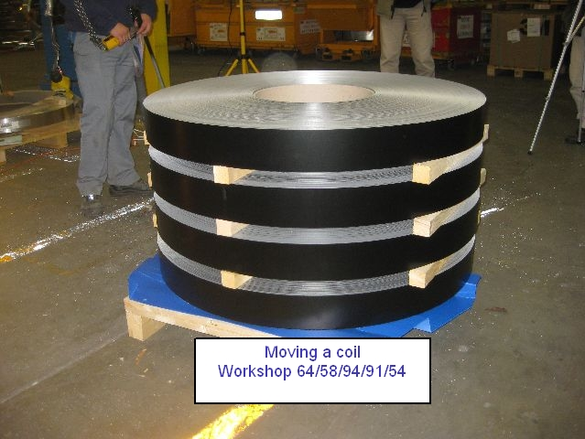
Tools
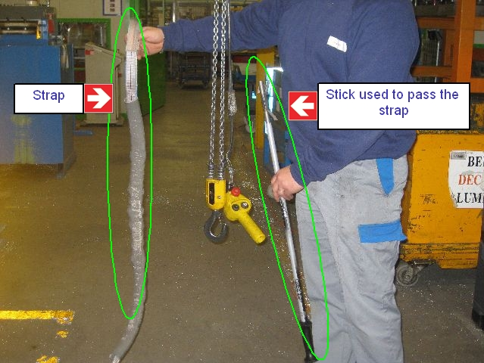

Operation 1 : Strapping
Basic operations | Security | Selfchecking | Instruction | Gestual
1- Prepare Tools |  |  |  | O
2- Strapping | compulsory gloves
3- Take off the stick |  |  |  | O
4- Pick up the strap
5- Fasten to the winch |  | Check the link  Check the quality of the link
6- Shift the coil |  |  | Pull on the strap and shift the coil

Instructions ?
Strapping the coil

Equipments ?
Strap and Stick. The stick is used to pass the strap beneath the coil

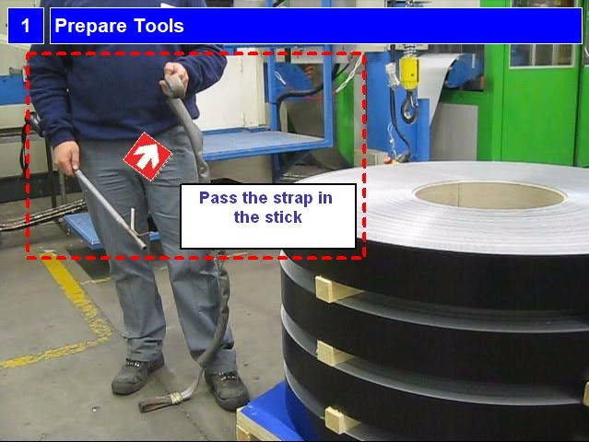
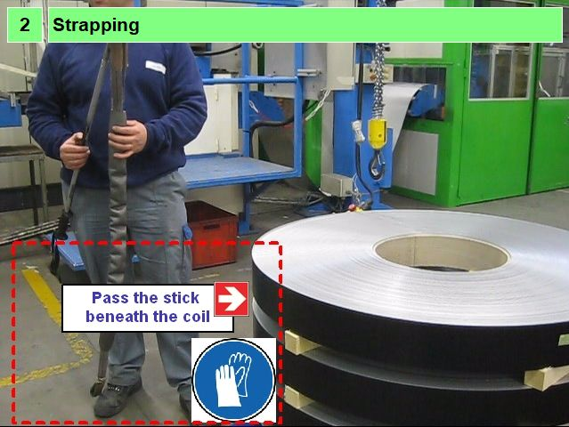
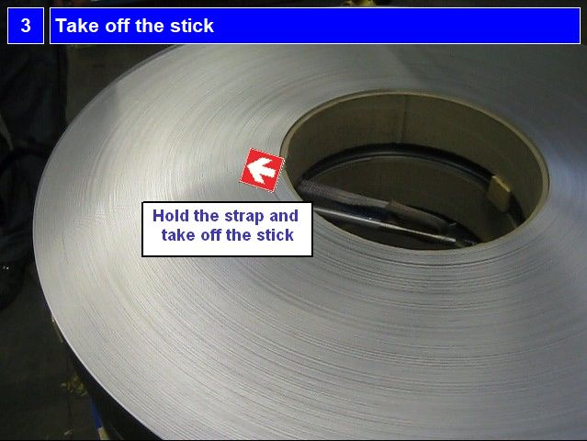
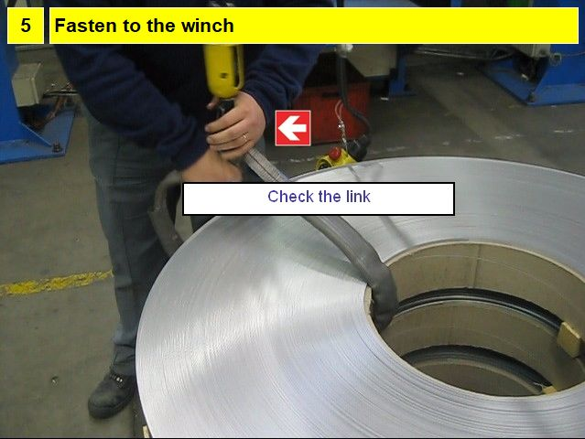
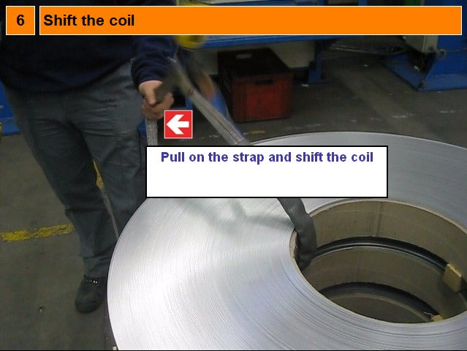
Operation 2 : Lift and turn the coil
Basic operations | Security | Selfchecking | Instruction | Gestual
1- The coil is shifted | Impacts risk, hazardious motion | The edge of the coil MUST be ON the next coil
2- Lift the coil
3- Turn the coil |  |  | Turn the tongue towards the machine
4- Check the position |  | O

Instruction ?
Lifting and moving the coil

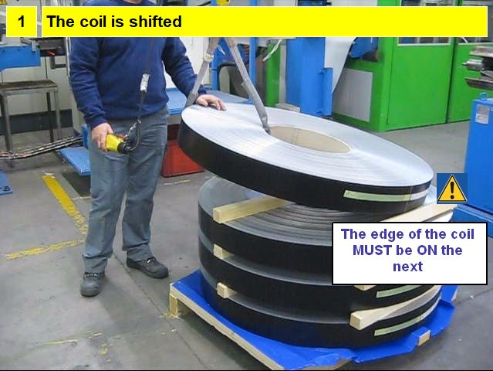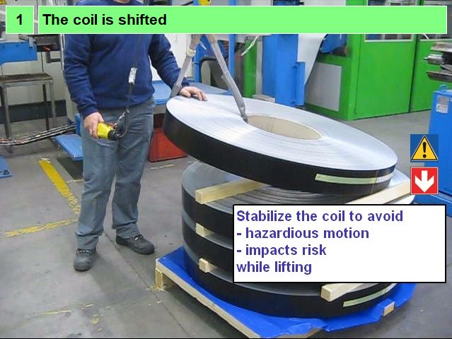
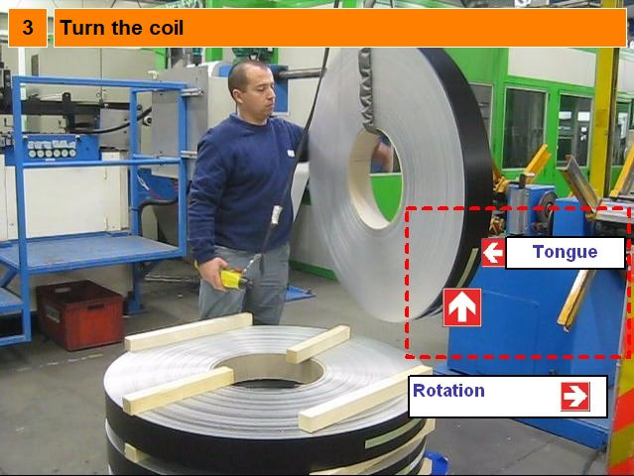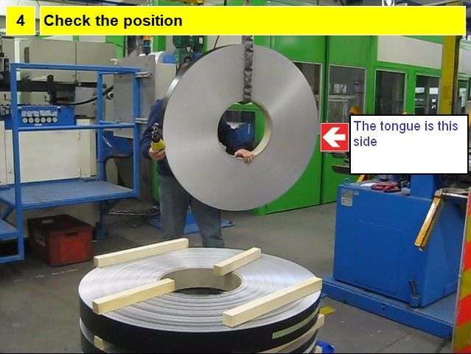
Point of particular attention 1 : Check the attachment of the hook with the strap
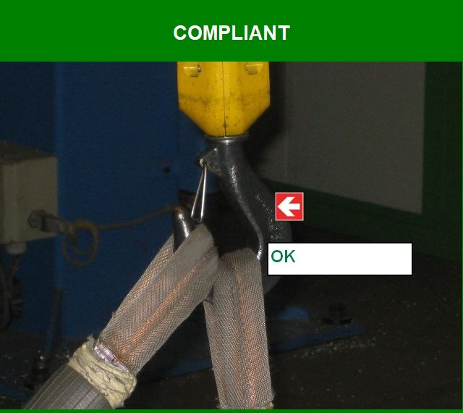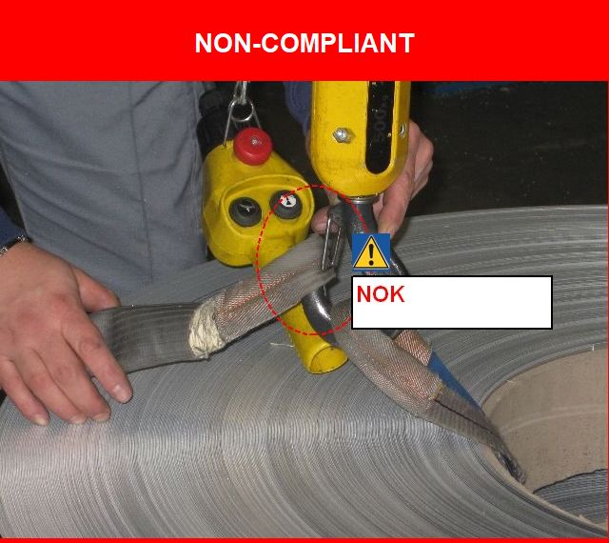

Point of particular attention 2 : Coil stability
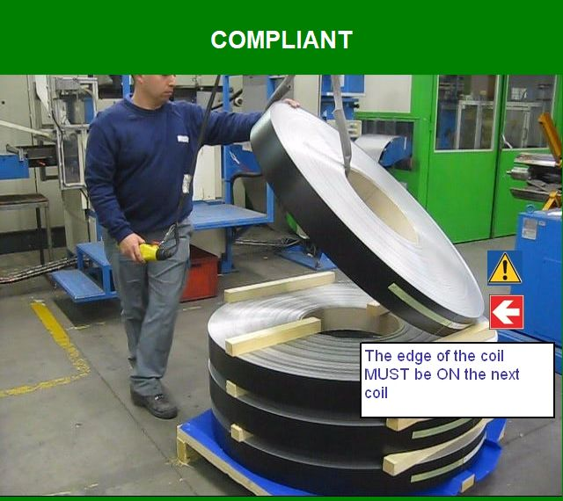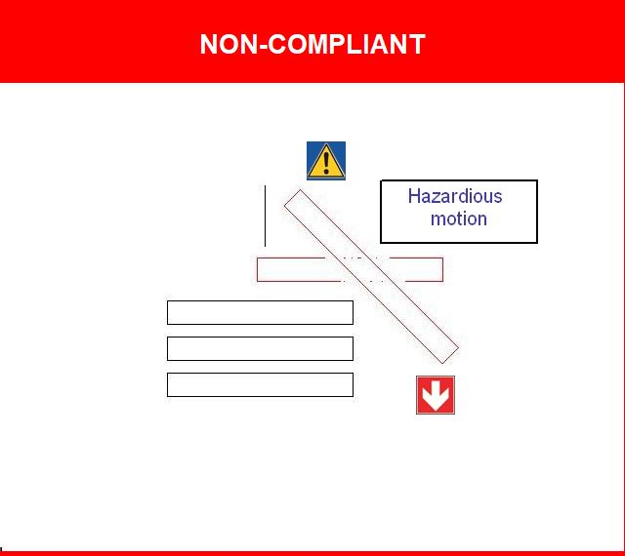
Stabilize the coil to avoid
- hazardious motion
- personal or material demages
while lifting

Point of particular attention 3 : Turn the coil (Tongue) towards the workstation
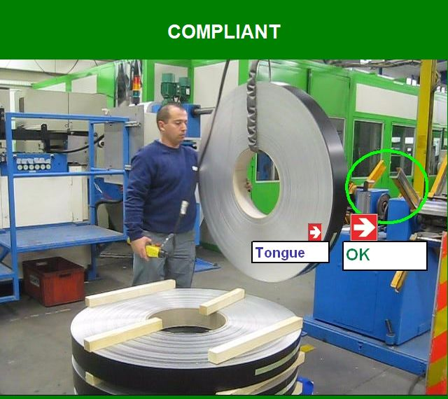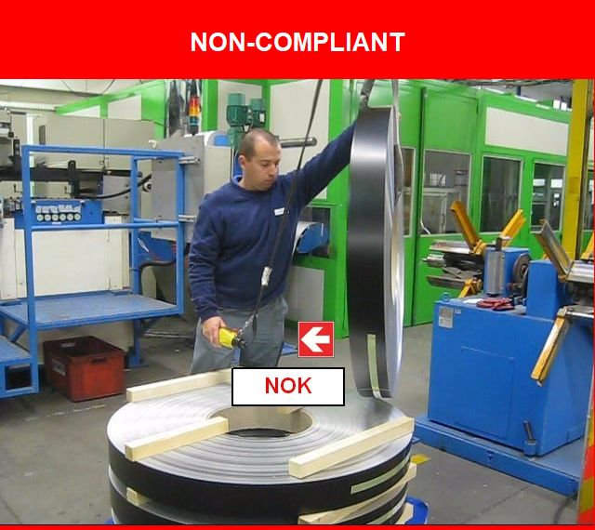
Turn the tongue towards the machine

